

HCI PROJECT REPORT

TITLE: COSMERA (COSMETIC APP)

SUBMITTED BY:
Shanza (2412289)
BSCS 3D

Submitted To:
SIR HUMAIR BUGHIO

Table of Contents

Introduction ............................................................. page 3
App overview ........................................................... page 4
Study & Working ...................................................... page 5
Features of App ......................................................... page 6
Prototyping ............................................................. page 7
Design Principles (HCI based) .................................. page 8 Conclusion .............................................................. page 9

Introduction

Human Computer Interaction (HCI) focuses on how people use digital systems and how these systems can be designed to be simple, comfortable, and easy to understand. A good application should help Users complete tasks without confusion, and its design must be visually clear & user friendly.

Our project, Cosmera, is a cosmetic shopping mobile application created using HCI principles. Many users today struggle to find suitable products online due to poor navigation or unclear product details. Cosmera solves these issues by offering an organized interface, clean product listings, smooth navigation, and helpful options like tracking, customers reviews, categories, and secure checkout.

The app follows a soft, elegant cosmetic theme with pink and nude colors, rounded shapes, high-quality product images, and simple navigation icons. A complete high-fidelity prototype of 43 screens was created using Figma to show the entire user journey.

Cosmera aims to make beauty shopping more comfortable, modern, and reliable for all users.

App Overview

Cosmera is an all-in-one cosmetic shopping app that helps users browse makeup, skincare, and perfumes easily. Instead of confusing options, the app organizes products into simple categories, provides descriptions, ingredients, shades, reviews, and allows users to save products or proceed to checkout

Key Goals of the App

To make cosmetic shopping simple and stress-free

To provide clear information about each product

To help users track and return products quickly

To create an elegant and smooth user experience

To follow strong HCI principles for better usability

- To check the product reviews before buying

- To contact us if they face any kind of difficulty

Cosmera is designed for beginners, beauty lovers, professional users, and anyone who prefers online cosmetic shopping.

Study & Working

In this project, we designed 43 high-fidelity screens in Figma to cover the complete journey of a cosmetic shopping application. Instead of making the design complicated, we used HCI principles to keep everything simple, clear, and easy for the user.

The 43 screens include all the essential parts of the app such as the splash screen, login, homepage, categories, customer reviews, product details, contact us, tracking, cart, checkout, user profile, settings, and other small supportive pages. Each screen is connected smoothly so the user can move step-by-step without confusion.

While creating the structure, we focused on how real users shop online. The layout guides the user naturally from browsing products → reading details → saving items → adding to cart → checking out → tracking items . All screens follow the same colors, fonts, and icon styles to maintain consistency.

The design also makes sure users understand what each button or icon does. Proper spacing, clear labels, and soft colors help reduce confusion and improve comfort. Overall, the 43-screen structure shows the complete working of a fully designed cosmetic shopping app built with simple and modern HCI principles.

Features of App

Cosmera includes several useful and practical features that keep cosmetic shopping easy and organized:
- Product Browsing
Users can explore makeup, skincare, and perfume products through clean and well-arranged categories.
- Product Details
Each product includes images, descriptions, ingredients, prices, ratings, and available shades or variants.
- Contact us
Users can easily contact via Instagram, twitter etc.
- Tracking
A simple tracking feature that users can track items easily.
- Cart & Checkout
The cart allows users to manage items easily, and the checkout process is fast and organized with multiple payment choices.
- User Profile
Users can edit their profile, check order history, and manage saved information.
- Clean UI Design
Soft colors, rounded icons, and neat spacing make the app visually comfortable and easy to use.

Prototyping

The prototype of Cosmera was made in Figma and has 43 screens that show how the whole app works. It includes all the main parts of the app, like the splash screen, login page, home page, product pages, tracking, return items, contact us, cart, and checkout. Each screen is designed with soft colors, clear buttons, and simple layouts so the user can move through the app easily. The prototype helps us see how the app will look and how a user will use it from start to end. It is a complete preview of the Cosmera application.
We also included a scrolling prototype. Which allows users to scroll through product lists and other content, just like in real app. Overall the prototype ensures that every interaction is smooth, intuitive and user- friendly.

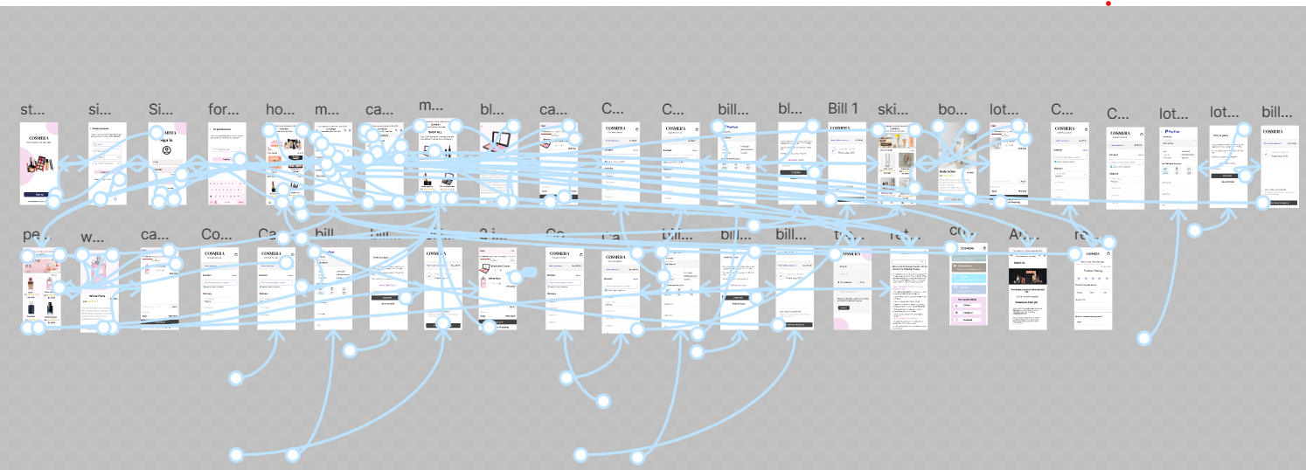

Design Principles (HCI Based)

Cosmera follows major HCI principles:

- Consistency
All screens follow the same color theme, icon style, and layout.
- Feedback
Buttons respond visually when tapped.
- Visibility
Icons, labels, and product information are clear and easy to find.
- Accessibility
Soft colors and readable fonts make the app comfortable for all users.
- Aesthetic & Minimalist Design
Only necessary information is shown. Extra distractions are removed to keep the interface clean and modern.
- User Control
Users can go back, edit cart items, remove products, or update preferences anytime without restrictions.
- Error Prevention
Clear labels and organized navigation reduce mistakes. The checkout process shows confirmation steps to avoid wrong orders.

Conclusion

Creating Cosmera helped us understand how HCI principles improve the user experience of a mobile application. From the splash screen to the login account, from choosing colors to designing button shapes and from adding to cart to buying products, every design choice influences how users feel and interact with the app.
Cosmera provides a smooth, organized, and modern cosmetic shopping experience. By focusing on clarity, simplicity, and usability, the app becomes accessible to all types of all users. When we make any app or project we have to create the best interface for all the users, we should be careful about colors , fonts, icons, everything else so that user feel comfortable while using the app. This project taught us that user-centered design is the key to making successful and meaningful digital applications. Paying attention to what users need and how they behave helps us make better design decisions.
In the end, a well-thought-out interface doesn’t just work, it feels good, is easy to use, and leaves a positive impression.
Cosmera showed us that small details really matter, and every choice counts in creating a smooth and enjoyable experience for users.

